**BE Assignment 4**

**BJT as Amplifier**

The below circuit diagram shows the working of the common emitter amplifier circuit and[it consists of voltage divider](https://www.elprocus.com/voltage-divider-rule-with-examples/) biasing, used to supply the base bias voltage as per the necessity. The voltage divider biasing has a potential divider with two resistors are connected in a way that the midpoint is used for supplying base bias voltage.

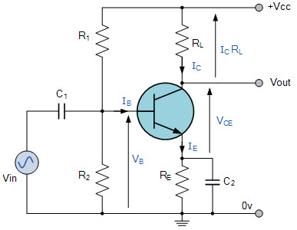

Common Emitter Amplifier Circuit

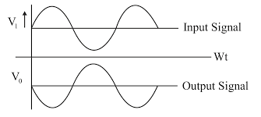

There are different [types of electronic components](https://www.elprocus.com/major-electronic-components/) in the common emitter amplifier which are

R1 resistor is used for the forward bias,

the R2 resistor is used for the development of bias,

the RL resistor is used at the output it is called the load resistance.

The RE resistor is used for thermal stability.

The C1 capacitor is used to separate the AC signals from the DC biasing voltage and the capacitor is known as [the coupling capacitor](https://www.elprocus.com/capacitors-types-applications/).

The figure shows that the bias vs gain common emitter amplifier transistor characteristics if the R2 resistor increases then there is an increase in the forward bias and R1 & bias are inversely proportional to each other.

The [alternating current](https://www.elprocus.com/main-difference-between-ac-and-dc-currents/)is applied to the base of the transistor of the common emitter amplifier circuit then there is a flow of small base current.

Hence there is a large amount of current flow through the collector with the help of the RC resistance.

The voltage near the resistance RC will change because the value is very high and the values are from 4 to 10kohm. Hence there is a huge amount of current present in the collector circuit which amplified from the weak signal, therefore common emitter transistors work as an amplifier circuit.

**JFET as Amplifier**

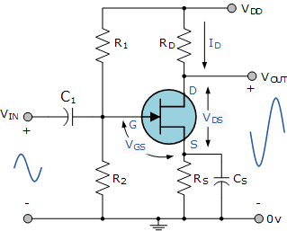

The amplifier circuit consists of an N-channel JFET, connected in a common source configuration.

The JFET gate voltage Vg is biased through the potential divider network set up by resistors R1 and R2 and is biased to operate within its saturation region which is equivalent to the active region of the bipolar junction transistor.

Unlike a bipolar transistor circuit, the junction FET takes virtually no input gate current allowing the gate to be treated as an open circuit. Then no input characteristics curves are required. We can compare the JFET to the bipolar junction transistor (BJT) in the following table.

### Comparison between JFET and BJT

|  |  |
| --- | --- |
| [JFET](https://www.theengineeringknowledge.com/introduction-to-jfet-junction-field-effect-transistor/) | [BJT](https://www.theengineeringknowledge.com/transistor-or-bjt-ac-models/) |
| It has Gate ( G ) in place of gate | It has Base ( B ) in place of Gate |
| It has Drain ( D ) instead of collector | It has a Collector ( C ) instead of a drain |
| It has a Source ( S ) terminal | It has Emitter, ( E ) terminla |
| It has Gate Supply ( VG ) | It has Base Supply, ( VB ) |
| It has Drain Supply, ( VDD ) | It has a Collector Supply, ( VCC ) |
| Ita has Drain Current, ( ID ) | It has Collector Current, ( IC ) instead of drain current |